Chapter: Network Security Infrastructure & Data Pipeline
-1Introduction:
This section outlines the development and deployment of a high-performance, real-time security data pipeline designed for the Hybrid AI-IDS project. The primary objective of this infrastructure is to facilitate the seamless ingestion, processing, and storage of massive network traffic logs with minimal latency. By converting raw network events into structured security features, this architecture ensures that the downstream AI models receive high-fidelity, consistent inputs for immediate threat detection and analysis.
-2Core Infrastructure Components-:
The security pipeline leverages a containerized architecture running inside a VMware virtual platform to ensure complete isolation and high availability. The infrastructure consists of four primary microservices:
- Apache Kafka: Operates as a distributed streaming platform and messaging queue, absorbing live network traffic bursts and protecting the system from data loss under high throughput.
- Logstash: Serves as the central processing engine, configured to automatically ingest raw log streams, parse complex data structures, and perform feature alignment.
- Elasticsearch: Acts as the distributed, real-time analytics database, storing and indexing all processed security logs under a dedicated index for instant query performance.
- Kibana: Provides the dedicated security operations center (SOC) visualization layer, connected directly to the database to generate live analytical charts and track traffic hits.
-3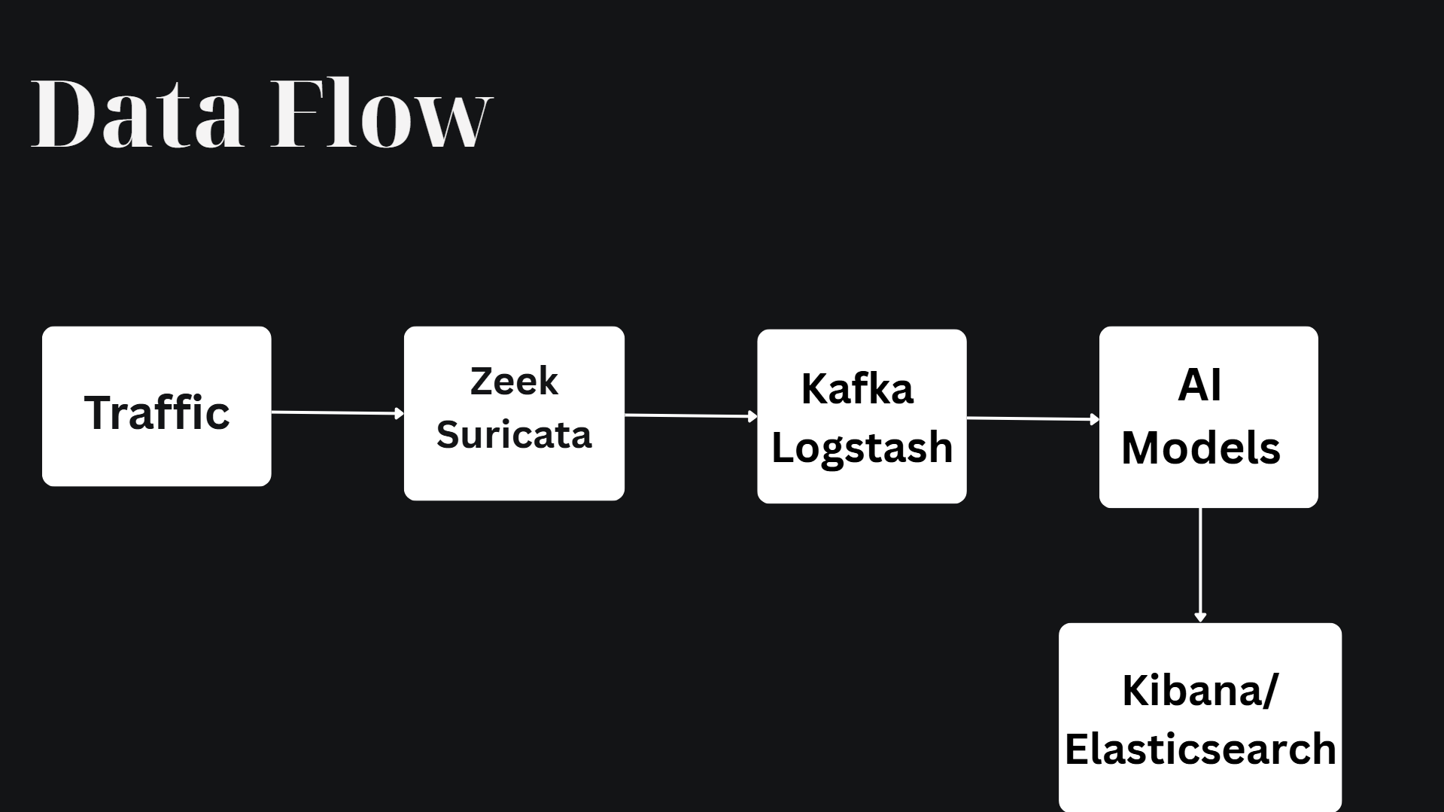
The data flow inside the architecture operates via a deterministic, low-latency pipeline. Raw data mimics real-world network operations, passing logs directly into Apache Kafka which buffers the incoming streams. Logstash automatically consumes these records, applying filters to parse and structure the traffic into the required security features. Once aligned, the logs are immediately indexed into Elasticsearch, triggering real-time visualization updates within the Kibana monitoring system.
-4Technical Implementation and Data Alignment:
To interface successfully with the machine learning component, the pipeline must standardize incoming logs. The raw fields are parsed using Logstash filtering rules to extract exactly 32 security features. This precise alignment ensures the structural integrity of the features perfectly matches the historical training dataset structure.
Additionally, the pipeline preserves the original Event Time (the native event timestamp embedded inside the raw logs). Maintaining this temporal context allows the downstream AI system to evaluate attack patterns in their correct chronological order.

5. Deployment Commands and Operational Management
The infrastructure is fully containerized and initialized using Docker Compose. Below are the sequential administrative commands utilized to deploy the pipeline, mitigate cluster storage limits, and inject traffic.
A. Pipeline Initialization
To boot up the core pipeline services (Kafka, Logstash, Elasticsearch, and Kibana) in detached mode, run:
docker-compose up -d
B. Cluster Storage Mitigation (Disk Watermark Bypass)
During operations within the virtualized platform, Elasticsearch automatically triggers a safety lock (index.blocks.read_only_allow_delete), switching indexes to a strict read-only state due to low disk watermark thresholds. To resolve this and prevent ingestion failures, the cluster settings are modified via API to allow processing up to 99% disk utilization, and the read-only flag is successfully removed using the following sequential commands:
curl -X PUT "localhost:9200/_cluster/settings" -H 'Content-Type: application/json' -d'
{
"persistent": {
"cluster.routing.allocation.disk.watermark.low": "99%",
"cluster.routing.allocation.disk.watermark.high": "99%",
"cluster.routing.allocation.disk.watermark.flood_stage": "99%",
"cluster.info.update.interval": "1m"
}
}'

curl -X PUT "localhost:9200/ids-logs/_settings" -H 'Content-Type: application/json' -d'
{
"index.blocks.read_only_allow_delete": null
}'

docker exec -i kafka-container kafka-console-producer --bootstrap-server localhost:9092 --topic network-traffic < mock_traffic.json
